Hopper | BD | D | L | R | S | W
170 Litre | 240mm | 620mm | 600mm | 148mm | 60mm | 400mm
880 Litre | 640mm | 1240mm | 1200mm | 195mm | 60mm | 800mm
1350 Litre | 600mm | 1380mm | 1200mm | 195mm | 60mm | 1200mm
2000 Litre | 1150mm | 1930mm | 1200mm | 195mm | 60mm | 1200mm

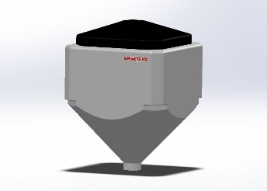
*Please Note – Freight cost additional

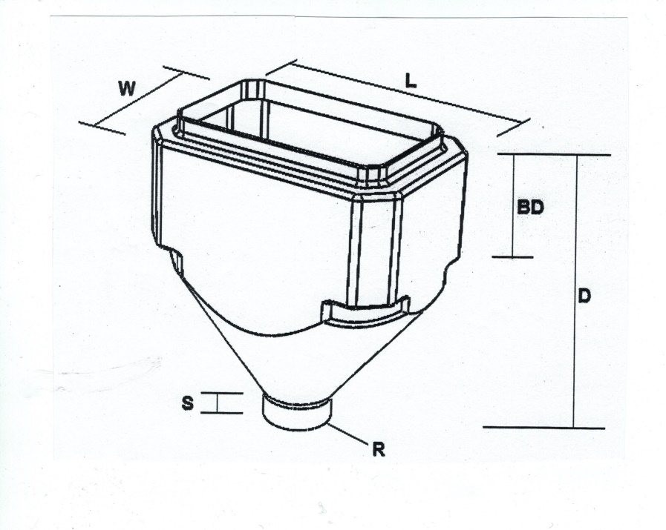

*MADE WITH HIGH QUALITY
FOOD GRADE PLASTIC

*AVAILABLE IN ANY COLOUR COMBO
*COMES COMPLETE WITH LID
*BOTTOM OF CONE COMES SEALED
CAN BE CUT UPON REQUEST

